**Section 0 – Use GIT as local VCS. Steps to follow:**

1. Create a directory ‘project_dir’ & ‘project_dir’.

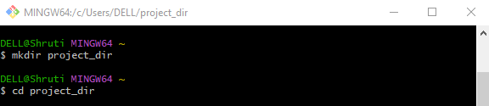

1. Initialize git version database



1. Create a new file index.html.



1. Check git status. You should find index.html as untracked file.

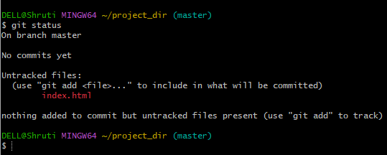

1. Stage the index.html file.

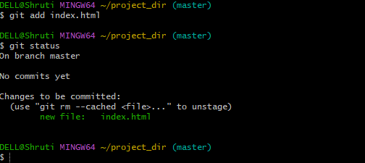

1. Commit index.html

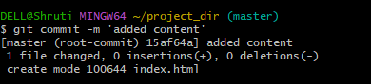

1. Make few changes in index.html & create a new file info.txt file.

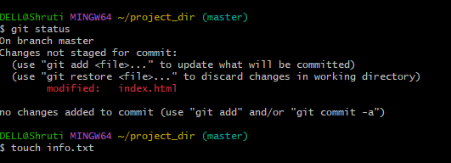

1. Check git status. You should find index.html & info.txt file.

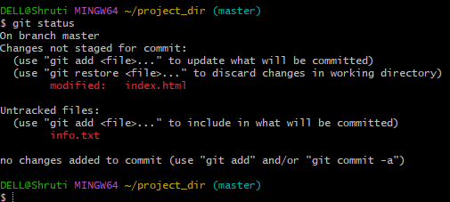

1. Configure GIT to ignore all txt files.

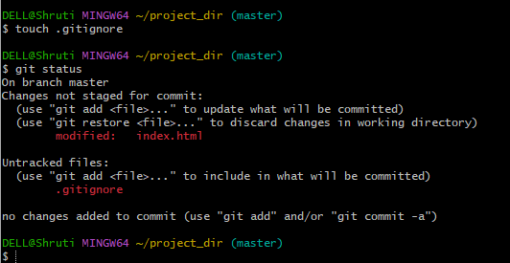

1. Again check the git status. You should find only index.html as untracked file.

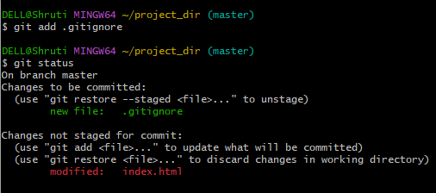

1. Stage and commit index.html

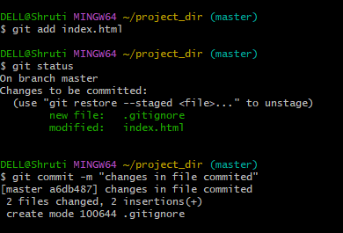

1. Log all your comments so far.

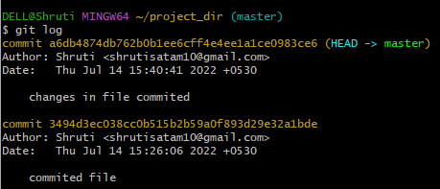

1. Make some changes in index.html

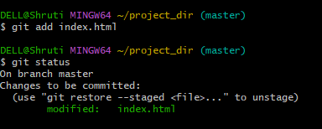

1. Revert the changes made in the previous step using git command

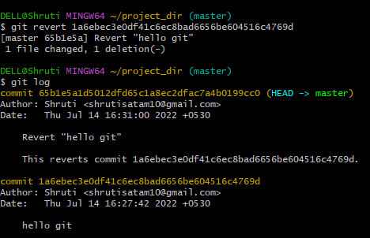

1. Again change index.html

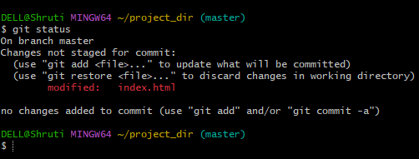

1. Stage index.html

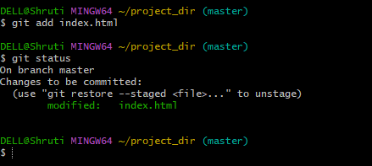

1. Revert back the last stage

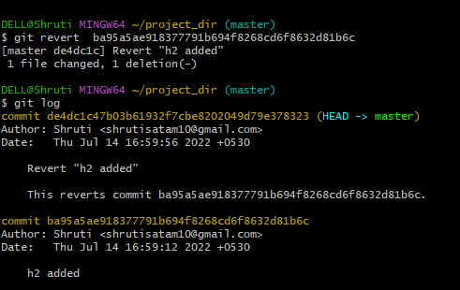

1. Rename ‘add’ command to ‘my-add’

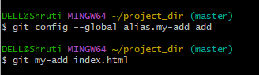

1. Using my-add command stage index.html again & commit the changes.

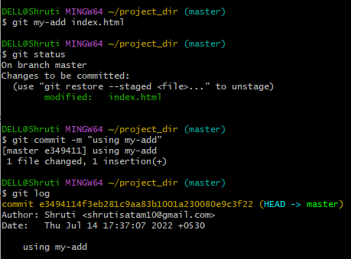

1. Revert the last Commit.

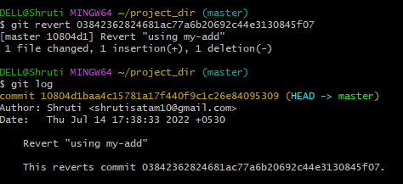

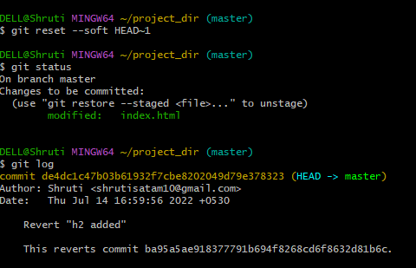

**GIT Branching**

Objective : Commit HTML<CSS & Javascript assignment into GIT

**SECTION – 1 ( HTML Assignment )**

1. Backup of assignment
2. Create empty directory “Assignments” & cd to Assignments

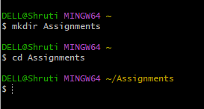

1. Create a file README.txt inside assignments & write few lines about contents of Assignment folder

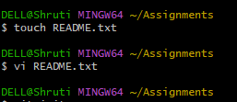

1. Commit README.txt file

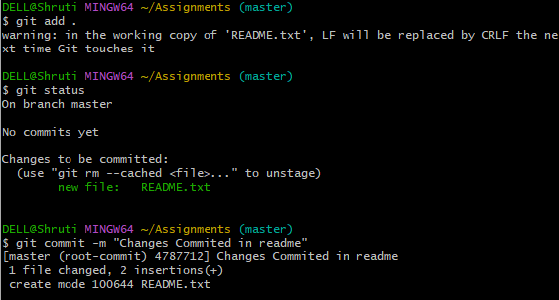

1. Create new branch ‘html-assignments’ .

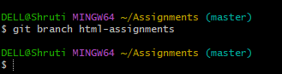

1. Switch to html-assignments branch



1. Copy all html assignments inside assignments folder.

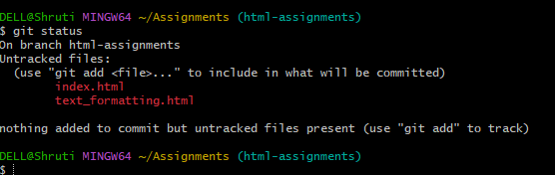

1. Commit HTML assignments into ‘html-assignments’ branch

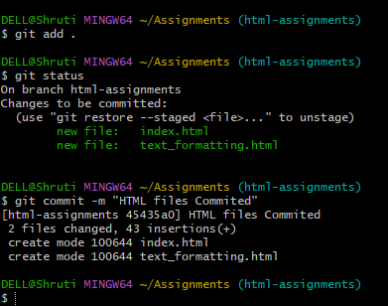

1. Make minor changes into few files belonging to html-assignments branch

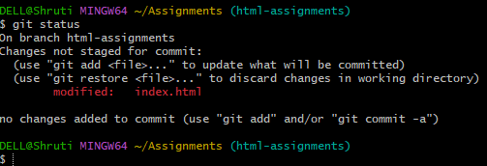

1. Commit those changed files

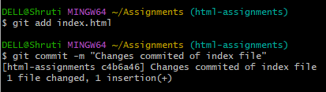

1. Switch to master branch

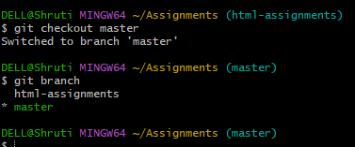

1. Make minor changes into README.txt file & commit those into master.

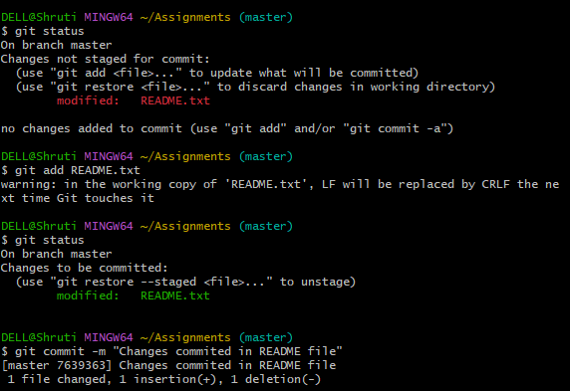

1. Again Switch to html-assignments branch

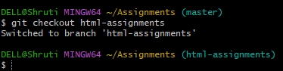

1. Make minor changes into few files belonging to html-assignments branch

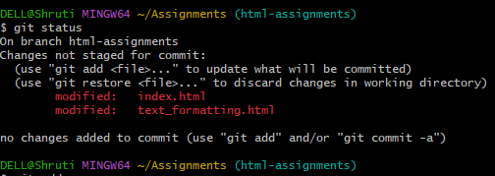

1. Commit those changes.

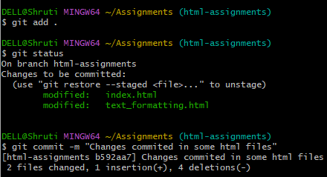

1. Switch to master.

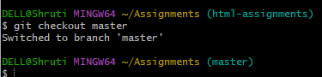

1. Merge ‘html-assignments’ branch into master. Confirm all html assignments are shown in master.

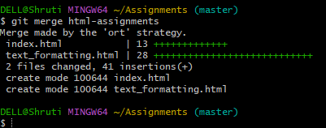

1. Finally delete ‘html-assignements’ branch

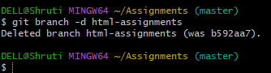

**SECTION – 2 ( CSS Assignment )**

1. Create new branch css-assignments



1. Switch to css-assignments inside Assignments folder



1. Copy all css assignments inside assignments folder

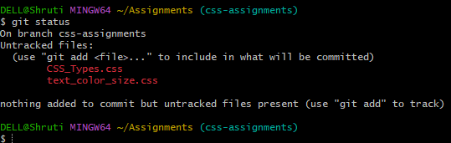

1. Commit css asignments into css-assignments branch

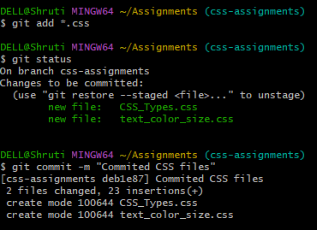

1. Make minor changes into README.txt file on line 1 belonging to css-assignments branch

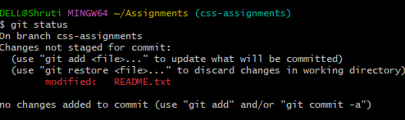

1. Commit those changed files

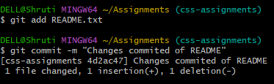

1. Switch to master branch



1. Make minor changes into README.txt file on line 3 belonging to master branch

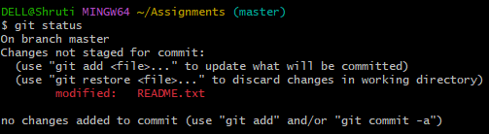

1. Again switch to css-assignments branch



1. Make minor changes into few files belonging to css-assignments branch

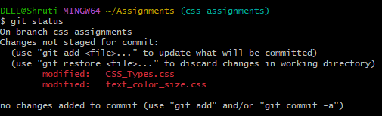

1. Commit those changes

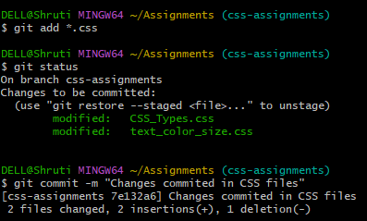

1. Switch to master branch



1. Merge ‘css-assignments’ branch into master. Confirm all css assignments are shown in master.

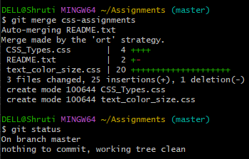

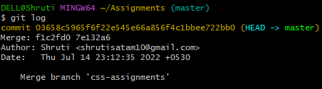

1. Finally delete csss-assignments branch



**SECTION – 3 ( Javascript Assignment )**

1. Create new branch ‘js-assignments’



1. Switch to js-assignments branch

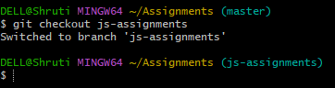

1. Copy all js assignments inside assignments folder

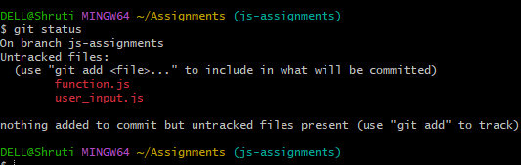

1. Commit javascript assignments into js-assignemnts branch

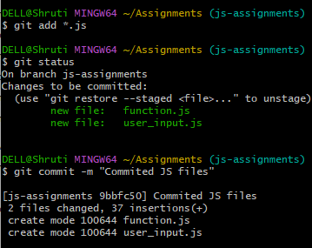

1. Make minor changes into README.txt file on line 1 belonging to css-assignments branch

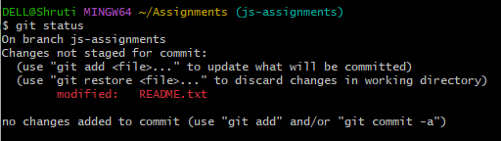

1. Commit those files

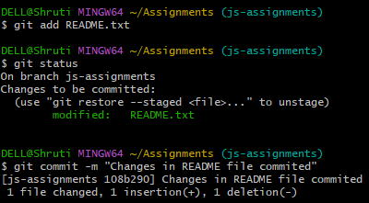

1. Switch to master branch



1. Make minor changes into README.txt file on line 1 & commit those changes into master branch

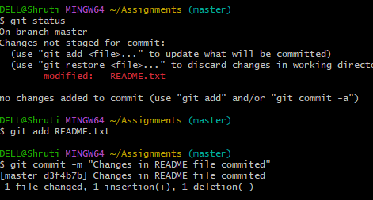

1. Again switch to js-assignments

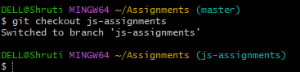

1. Make minor changes into few files belonging to js-assignments branch

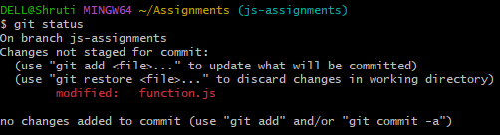

1. Commit those changes

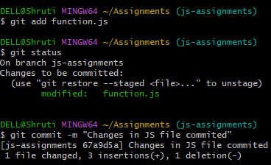

1. Switch to master branch



1. Merge ‘js-assignments’ branch into master. Confirm all js assignments are shown in master



1. Finally delete js-assignments branch



**GIT Remoting**

Objective : Pushing source code into GITHUB & collaborate team members

**SECTION 4 ( Pushing assignments to remote repository)**

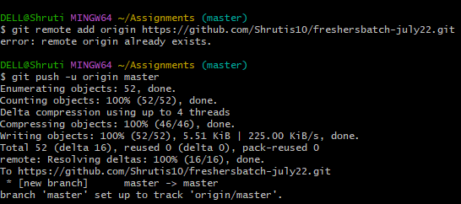

**SECTION 5 ( Pushing source code to remote repository using eclipse plugin)**